***\*\* To Submit all this Exercise Create a Single word file and copy all your scripts along with screenshot of the OutPut. And Share it on nehalole1115@gmail.com***

**Create Table Exercise**

**1).** The aim of this exercise is to **CREATE** the table with two columns (one to hold the name of the the category and the other to hold the COUNT of films):

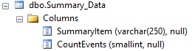

*Feel free to use more imaginative column names.*

Optionally save this as **Going Places.sql**and then close it down.

**2)**The aim of this exercise is to create a new summary table listing all the continents. Write a **Create** statement which returns the following **Continent_Summery** table

 then look in **Object Explorer**to check the new table exists:

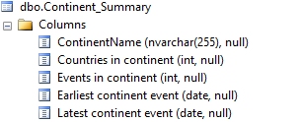

*If the table doesn't appear, try refreshing the tables folder.*

Optionally save this as **Continental Counting.sql**, and close it down.

**3)** Write code to generate a table of genres of author called **tblGenre**

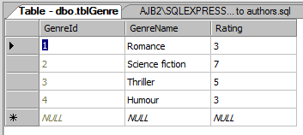

*Suggested genres to type in - feel free to use your own!*

Optionally, save this query or procedure as **Genres linked to authors.sql**, then close it

down.

**4)** Write SQL to create a new table to contain the Doctor Who production companies, beginning like this:

 Your table should have the following columns:

|  |  |
| --- | --- |
| **Column** | **Notes** |
| **ProductionCompanyId** | The unique number of each company (starting at 1, and going up by 1 for each new company) |
| **ProductionCompanyName** | The name of each company |
| **Abbreviation** | The abbreviation for each company |

Optionally, save your query as **Manual would have been quicker.sql**, then close it down.

**Insert Data Exercise**

1. You have Already Created **Continent_Summary** Table.Now Just add Following Data in to it.

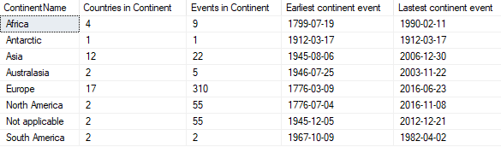

1. Add code to insert records into Genre table then display them - here's a suggestion for what to add:

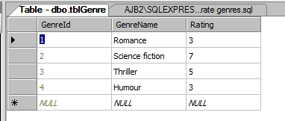

*If you don't like science fiction, your ratings will be different*

Run your query to check it works - you should see something like this:

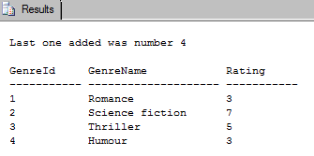

1. Insert data in to Summery_Data Table.

Run your query to check it works - you should see something like this:

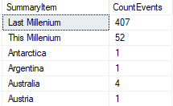

1. Insert Data in to Continent_Summery , which returns the following summary data for each continent.

Run your query to check it works - you should see something like this:



***(Perform these Exercise on WorldEvents Database)***

**Select Command Exercise**

1. Create a query to list out the following columns from the tblEvent table a. The event name b. The event date
2. Create a query to list out the id number and name of the top 3 categories from the tblCategory table
3. Write a query to show the first 5 events (in date order) from the tblEvent table
4. Create a query to show the first 2 events from the tblEvent table

**Where Clause Exercise**

1. Write a query to list out all of the events from the tblEvent table in category number 11
2. Create a query which lists out all of the events which took place in February 2005
3. Show a list of all : a. They take place in one of the island countries (8, 22, 30 and 35, corresponding to Japan, the Marshall Islands, Cuba and Sri Lanka respectively) b. Their category is number 4 (Natural World)
4. Query to show:

a. Events which aren't in the Transport category (number 14 ).

b. Events which are in the Space country (number 13).

c. Events which are in categories 5 or 6 (War/conflict and Death/disaster),

1. Create a query which lists out all of the tblEvent events which include the word Teletubbies